|  | | No.: | | --- | |
| --- | --- | --- |



**Parental Consent Form**

Name of Student Organization: Society for the Welfare of Information Technology Students (SWITS)____

Name of Activity: 12th IT Congress ________________________________________________________

Nature of Activity: Co-Curricular Extra-Curricular

Face to Face Activity: Online Activity:

Venue: Malolos Sports and Convention Center__ Online Platform: ______________________________

Inclusive Dates: November 17, 2022 – November 18, 2022_____________________________________

I allow my son/daughter to attend the online activity.

I trust that the organizers of this activity will take due diligence to ensure the safety of my son/daughter as a participant.

I do not allow my son/daughter to attend the activity.

Name of Student: Nicole Marie B. Abadillos

Name of Parent/Guardian: Romeo II Venus Abadillos

Phone/Cell phone number: 09384147834

Address: Blk. 92 Lot 5 Area D Purok 1 Sta. Cruz CSJDM Bulacan

Signature: 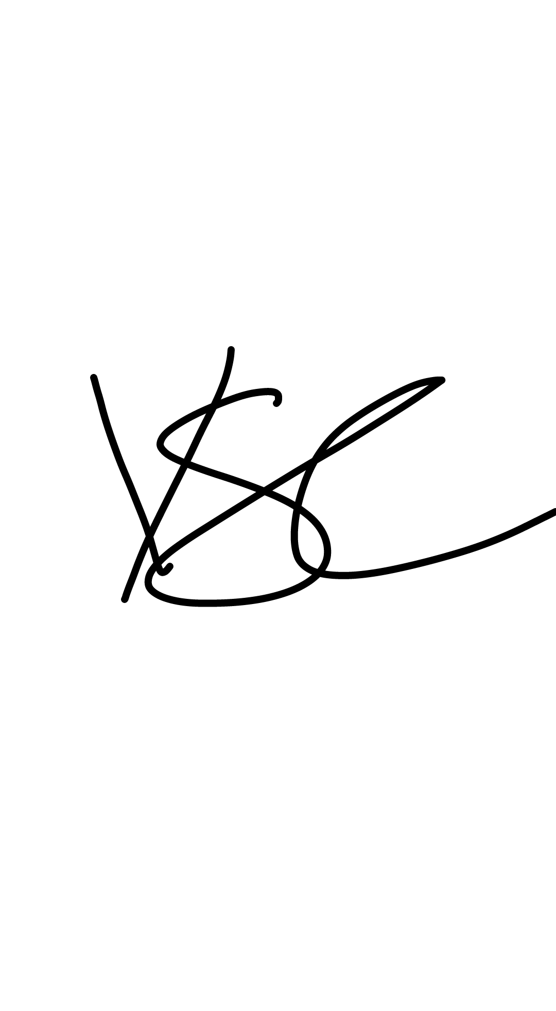

*\*Please attach a scanned copy of Identification Card (ID) of the parent/guardian.*

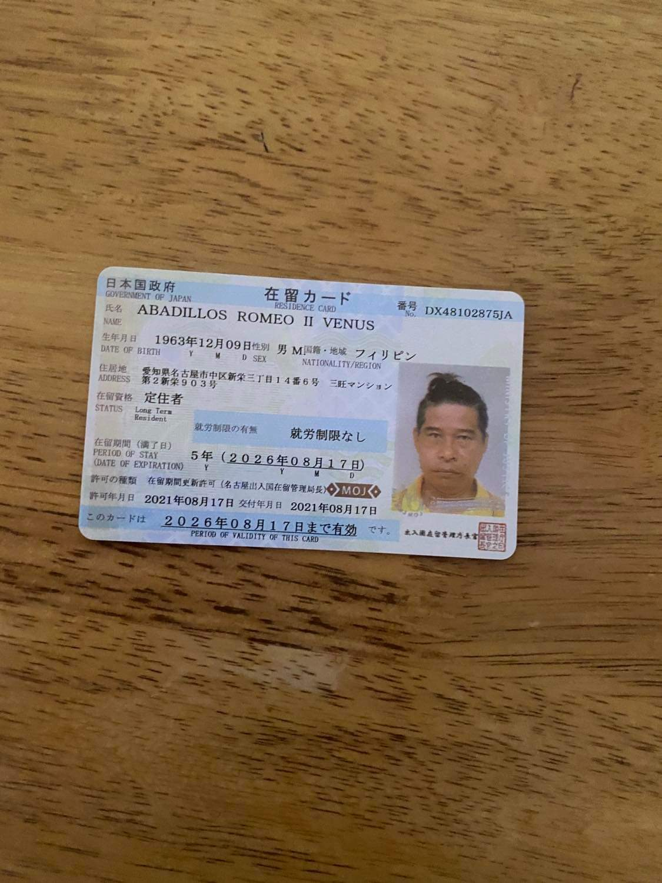

*Insert student vaccination card\**

